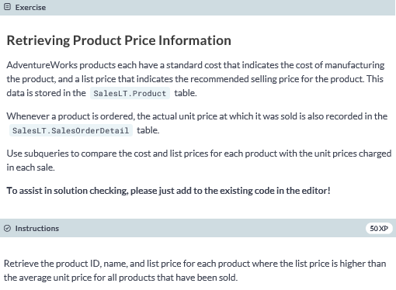

**-- select the ProductID, Name, and ListPrice columns**

**SELECT ProductID, Name, ListPrice**

**FROM SalesLT.Product**

**-- filter based on ListPrice**

**WHERE ListPrice >**

**-- get the average UnitPrice**

**(SELECT AVG(UnitPrice) FROM SalesLT.SalesOrderDetail)**

**ORDER BY ProductID;**

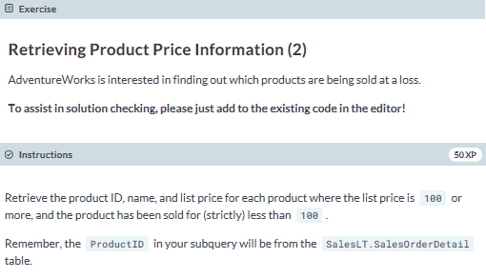

**SELECT ProductID, Name, ListPrice**

**FROM SalesLT.Product**

**WHERE ProductID IN**

**-- select ProductID from the appropriate table**

**(SELECT ProductID FROM SalesLT.SalesOrderDetail**

**WHERE UnitPrice < 100)**

**AND ListPrice >= 100**

**ORDER BY ProductID;**

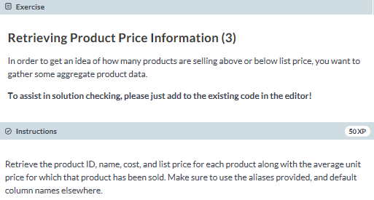

**SELECT ProductID, Name, StandardCost, ListPrice,**

**-- get the average UnitPrice**

**(SELECT AVG(UnitPrice)**

**-- from the appropriate table, aliased as SOD**

**FROM SalesLT.SalesOrderDetail AS SOD**

**-- filter when the appropriate ProductIDs are equal**

**WHERE P.ProductID = SOD.ProductID) AS AvgSellingPrice**

**FROM SalesLT.Product AS P**

**ORDER BY P.ProductID;**

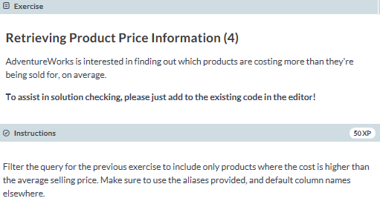

**SELECT ProductID, Name, StandardCost, ListPrice,**

**(SELECT AVG(UnitPrice)**

**FROM SalesLT.SalesOrderDetail AS SOD**

**WHERE P.ProductID = SOD.ProductID) AS AvgSellingPrice**

**FROM SalesLT.Product AS P**

**-- filter based on StandardCost**

**WHERE StandardCost >**

**-- get the average UnitPrice**

**(SELECT AVG(UnitPrice)**

**-- from the appropriate table aliased as SOD**

**FROM SalesLT.SalesOrderDetail AS SOD**

**-- filter when the appropriate ProductIDs are equal**

**WHERE P.ProductID = SOD.ProductID)**

**ORDER BY P.ProductID;**

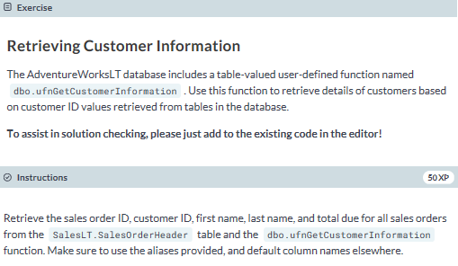

**-- select SalesOrderID, CustomerID, FirstName, LastName, TotalDue from the appropriate tables**

**SELECT SalesOrderID, SOH.CustomerID, FirstName, LastName, TotalDue**

**FROM SalesLT.SalesOrderHeader AS SOH**

**-- cross apply as per the instructions**

**CROSS APPLY dbo.ufnGetCustomerInformation(SOH.CustomerID) AS CI**

**-- finish the clause**

**ORDER BY SOH.SalesOrderID;**

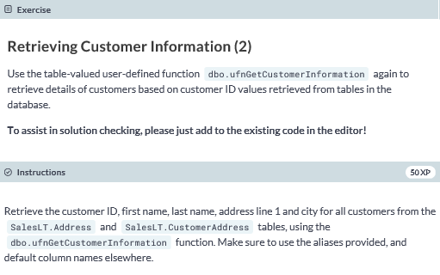

**-- select the CustomerID, FirstName, LastName, Addressline1, and City columns from the appropriate tables**

**SELECT CI.CustomerID, CI.FirstName, CI.LastName, A.AddressLine1, A.City**

**FROM SalesLT.Address AS A**

**JOIN SalesLT.CustomerAddress AS CA**

**-- join based on AddressID**

**ON A.AddressID = CA.AddressID**

**-- cross apply as per instructions**

**CROSS APPLY dbo.ufnGetCustomerInformation(CA.CustomerID) AS CI**

**ORDER BY CA.CustomerID;**